|  |  |  |  |
| --- | --- | --- | --- |
| **Course Code:** | **ECE1002** | **Course Name:** | **Semiconductor Devices and Circuits Lab** |
| **Faculty In – Charge:** | **Dr. Pradeep Naryanan S.** | **Department:** | **SENSE** |
| **Name of the Student:** | **Aryan Pandey** | **Registration Number:** | **20BLC1087** |
| **Experiment No.:** | **4** | **Date of Experiment:** | **05.04.2021** |
| **Name of the Experiment:** | **DESIGN AND VERIFICATION OF FULL WAVE RECTIFIER WITH FILTER AND WITHOUT FILTER** | | |

**OBJECTIVE:**

To design and verify the function of the Full Wave Rectifier with and without filter using LT Spice Simulator and observe its characteristics.

**TOOLS:**

LT Spice XVII Simulator.

**THEORY**

**FULL WAVE RECTIFIER: -**

A Rectifier is said to be centre tapped if it can rectify both the positive and the negative halves of the cycle. By using a transformer with a presence of wire at the secondary winding it makes the transformer centre tapped. This is the reason it is termed as a Centre Tapped Full Wave Rectifier.

The reason behind using this type of transformer is that it can utilize both halves of the cycle by connecting two diodes respectively. Compare to half-wave rectifier centre tapped full wave has greater efficiency. The rectifier is classified into two types.

* Half wave Rectifier
* Full wave rectifier.

A half-wave rectifier is fined as a type of rectifier that only allows one half-cycle of an [AC voltage waveform](https://aarvis.com/lt-spice-ac-analysis/) to pass, blocking the other half-cycle. Half-wave rectifiers are used to convert AC voltage to [DC voltage](https://aarvis.com/learn-dc-transfer-function-using-ltspice/). It is done by using a diode or a group of diodes.

A full-wave rectifier converts both halves of each cycle of an alternating wave (AC signal) into a pulsating DC signal.

A full wave rectifier is classified in two types: -

* Centre Tapped Rectifier
* Bridge Rectifier

We are discussing the Centre-Tapped Rectifier in LT Spice. In the case of this only two diodes are used and they are connected to the opposite ends of a secondary transformer as shown in the figure below.

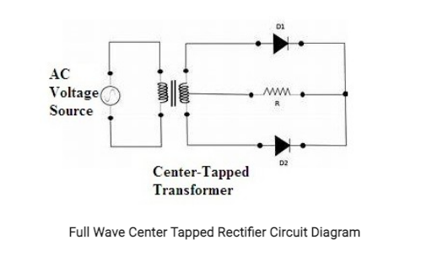

**PROCEDURE**

**Without Filter: -**

1. **Draw the AC voltage source: -**

Transformer input is connected into the main AC supply. The normal ac input voltage is 230V and 50 Hz. Peak Voltage= 1.414 x VRMS. Here, VP x P = 1.414 x 230 = 325V.

Construct this, click on the component icon in the LT Spice and select voltage source and Click Ok. Right-click on the voltage source, Click on the advanced button.

By clicking the advanced button a pop-up window will open. In this window, you will have multiple options to select. Examples “PULSE”, “SINE”, etc.

Here we need a “SINE” waveform and provide the values in the corresponding fields.

* DC Offset = 0
* Amplitude = 162.5 = (325/2)
* Frequency = 50Hz
* AC amplitude = 162.5
* Series Resistance = 0.001Ω

#### ****Draw the Transformer: -****

* Click on the Inductor L1 and rename the L1 as LP which is the Primary Winding of Transformer. Similarly, change the name of L2 as LS1 which is Secondary Winding of Transformer and the name of L2 as LS2  which is also the Secondary Winding of Transformer.
* Setting the turns ratio of the transformer is simply a matter of choosing the right inductor values.
* Remember, the inductance is proportional to the square of the turns ratio. In the example above, a turns ratio of 3:1 gives a 9:1 inductance ratio. that means the value of inductor (LP) is 1800µF and the value of inductor (LS) is 200µF.
* “K1 LP1 LS1 LS2 1”- K is the coefficient of Coupling. Its values are between 0 and 1 - “1” means the winding is perfectly coupled.

1. **Draw the Diode: -**

Click on the diode button and position it on the required place on the screen. Right-click on the diode and click “Pick New diode” and select “1N4148 Silicon Diode”.

1. **Draw the Resister: -**

Click on the Resister and position it on the required place on the screen. Right click on the resister and type the value. Now, the last step is to label the input and output port. Click on the “label net” icon. If you want to label the input port, then type Vin and port type “input”. Similarly, if you want to label the output port then type Vout and port type “output”. Then place the input and output label to the corresponding place on the screen.

1. **Simulation of Full-Wave Centre Tapped Rectifier: -**

Click on the “Simulate” button and select “Edit Simulation Command”. Now, you will see a pop-up window. For the Rectifier, we have to plot the waveform in the time domain. We are using transient analysis here.

Click on “Transient Analysis” and a submenu will appear. In this only enter the stop value = 100ms. Then, click the “Run” button. Run button is available in the simulate icon on the title bar.

You will see the graphical window on your screen. In order to display both the input and output simultaneously in one plane, right click on the graphic plane and click on the “add plot” plane. Then two plane will appear. For displaying the input and output, right click on the graphic plane and then click on the add traces.

**With Filter: -**

1. **Draw the AC voltage source: -**

Transformer input is connected into the main AC supply. The normal ac input voltage is 230V and 50 Hz. Peak Voltage= 1.414 x VRMS. Here, VP x P = 1.414 x 230 = 325V.

Construct this, click on the component icon in the LT Spice and select voltage source and Click Ok. Right-click on the voltage source, Click on the advanced button.

By clicking the advanced button a pop-up window will open. In this window, you will have multiple options to select. Examples “PULSE”, “SINE”, etc.

Here we need a “SINE” waveform and provide the values in the corresponding fields.

* DC Offset = 0
* Amplitude = 162.5 = (325/2)
* Frequency = 50Hz
* AC amplitude = 162.5
* Series Resistance = 0.001Ω

#### ****Draw the Transformer: -****

* Click on the Inductor L1 and rename the L1 as LP which is the Primary Winding of Transformer. Similarly, change the name of L2 as LS1 which is Secondary Winding of Transformer and the name of L2 as LS2  which is also the Secondary Winding of Transformer.
* Setting the turns ratio of the transformer is simply a matter of choosing the right inductor values.
* Remember, the inductance is proportional to the square of the turns ratio. In the example above, a turns ratio of 3:1 gives a 9:1 inductance ratio. that means the value of inductor (LP) is 1800µF and the value of inductor (LS) is 200µF.
* “K1 LP1 LS1 LS2 1”- K is the coefficient of Coupling. Its values are between 0 and 1 - “1” means the winding is perfectly coupled.

1. **Draw the Diode: -**

Click on the diode button and position it on the required place on the screen. Right-click on the diode and click “Pick New diode” and select “1N4148 Silicon Diode”.

1. **Draw the Resister: -**

Click on the Resister and position it on the required place on the screen. Right click on the resister and type the value. Now, the last step is to label the input and output port. Click on the “label net” icon. If you want to label the input port, then type Vin and port type “input”. Similarly, if you want to label the output port then type Vout and port type “output”. Then place the input and output label to the corresponding place on the screen.

1. **Draw a Capacitor: -**

Place it in the required position with 100µF of Capacitance and add ground to both the Primary and Secondary coil.

1. **Simulation of Full-Wave Centre Tapped Rectifier: -**

Click on the “Simulate” button and select “Edit Simulation Command”. Now, you will see a pop-up window. For the Rectifier, we have to plot the waveform in the time domain. We are using transient analysis here.

Click on “Transient Analysis” and a submenu will appear. In this only enter the stop value = 100ms. Then, click the “Run” button. Run button is available in the simulate icon on the title bar.

You will see the graphical window on your screen. In order to display both the input and output simultaneously in one plane, right click on the graphic plane and click on the “add plot” plane. Then two plane will appear. For displaying the input and output, right click on the graphic plane and then click on the add traces.

**VERIFICATION OF FULL WAVE RECTIFIER**

**WITHOUT FILTER: -**

Full Wave Rectifier Circuit without a filter. The process of converting alternating current into direct current is rectification. Any offline power supply unit has the block of rectification which converts either the AC wall receptacle source into a high voltage DC or stepped down AC wall receptacle source into low voltage DC.

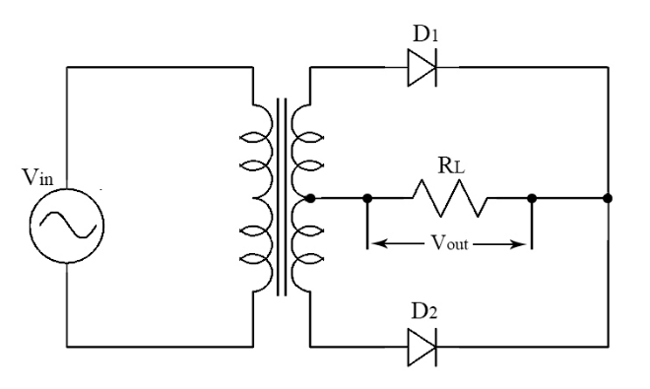

**Components Required: -**

* Voltage Source
* 2 Diodes
* Resistors
* Wires
* Inductors (which acts as Transformer)
* Ground

**Logic Diagram: -**

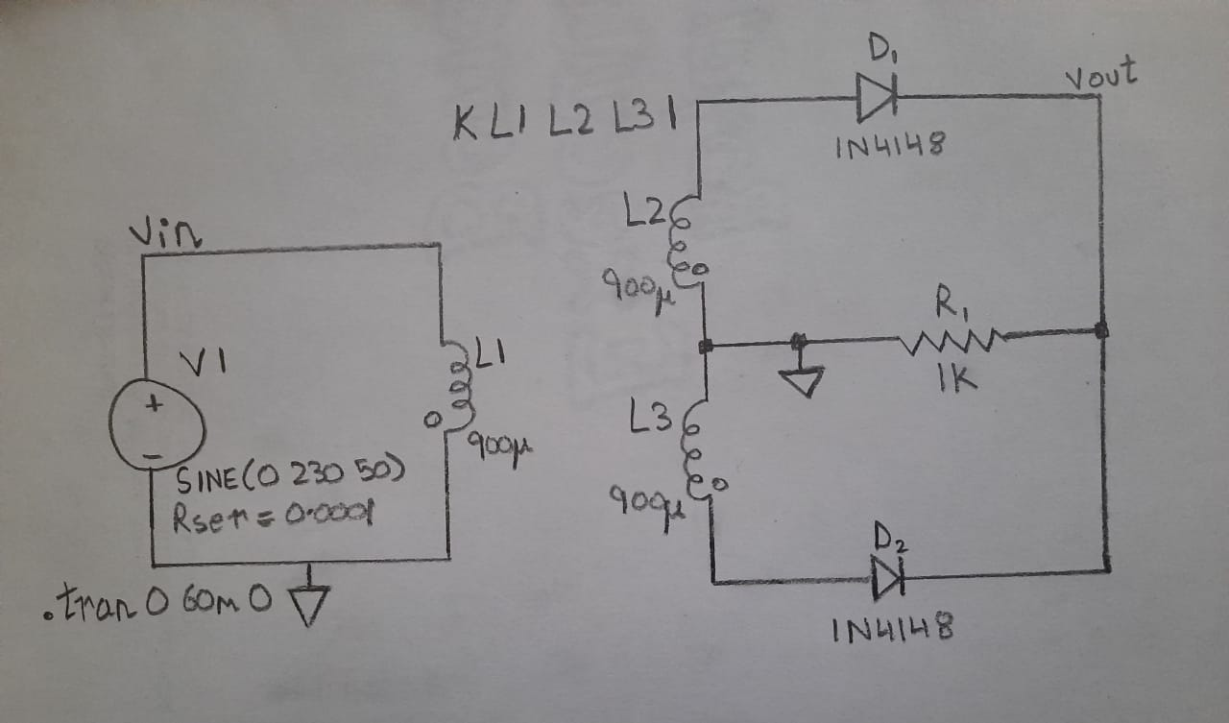

**Simulator Diagram - Schematic: -**

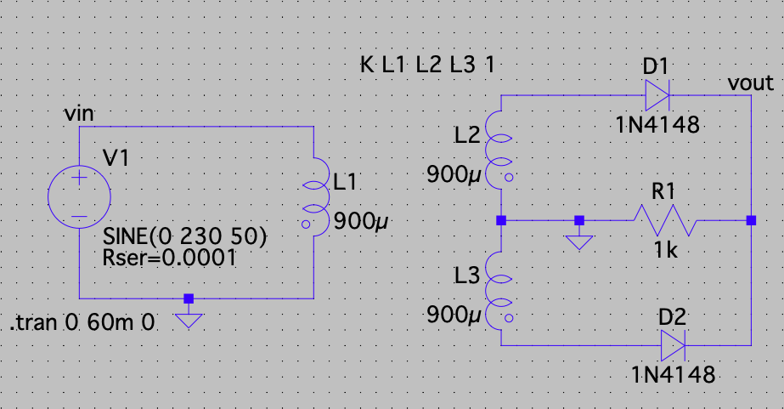

**Outputs: -**

**Input Waveform: -**

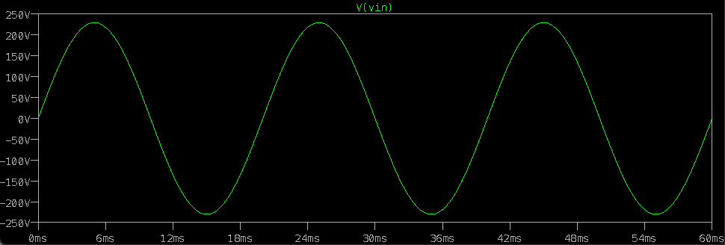

**Output Waveform: -**

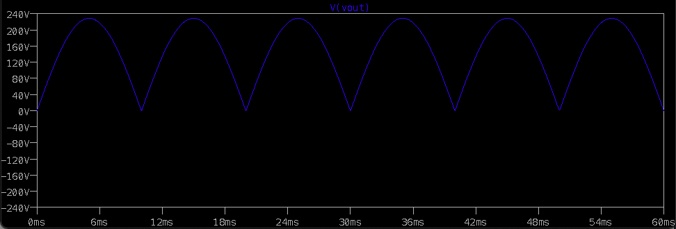

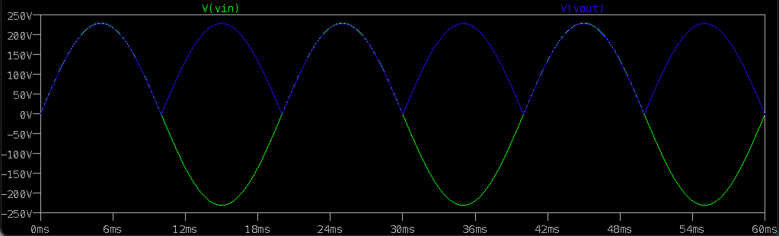

**WITH FILTER: -**

The main function of full wave rectifier is to convert an AC into DC. As the name implies, this rectifier rectifies both the half cycles of the I/P AC signal, but the DC signal acquired at the O/P still have some waves. To decrease these waves at the O/P this filter is used.

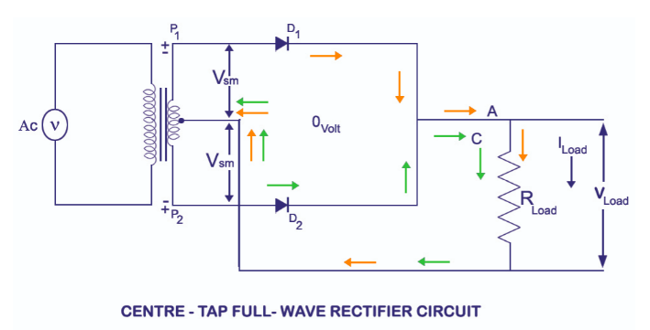

**Components Required: -**

* Voltage Source
* 2 Diodes
* Resistors
* Wires
* Inductors (which act as Transformer)
* Ground

**Logic Diagram: -**

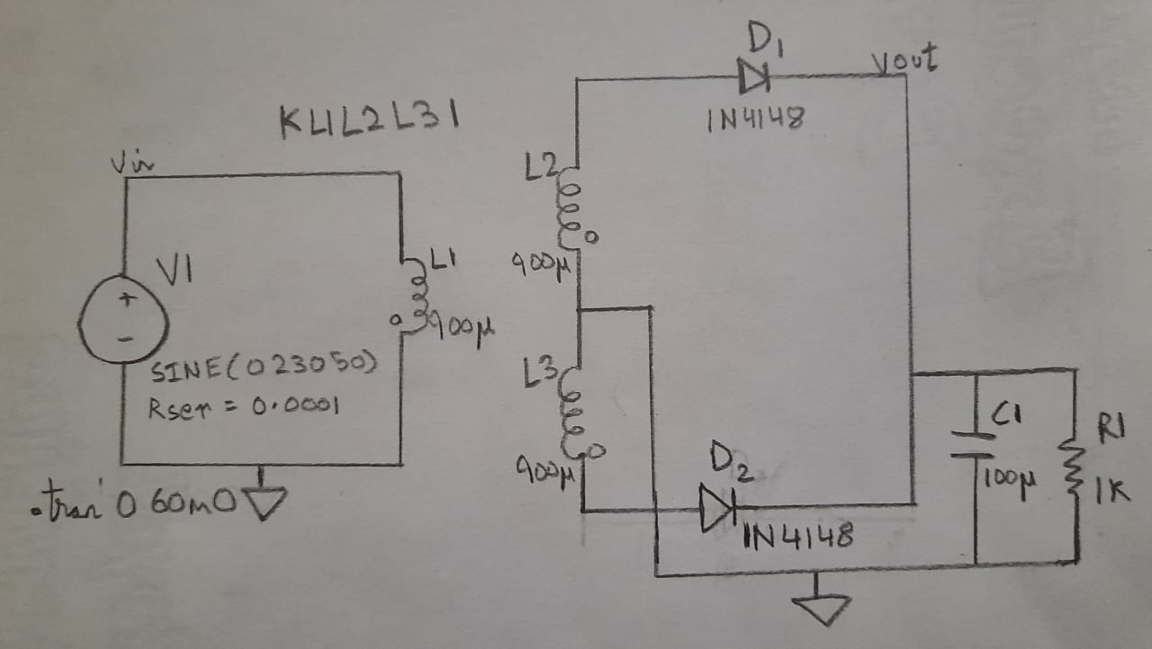

**Simulator Diagram - Schematic: -**

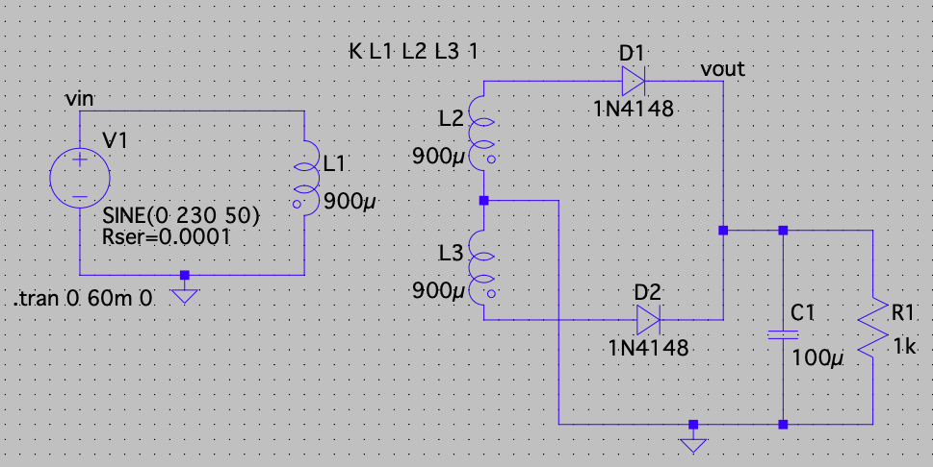

**Outputs: -**

**Input Wave Form: -**

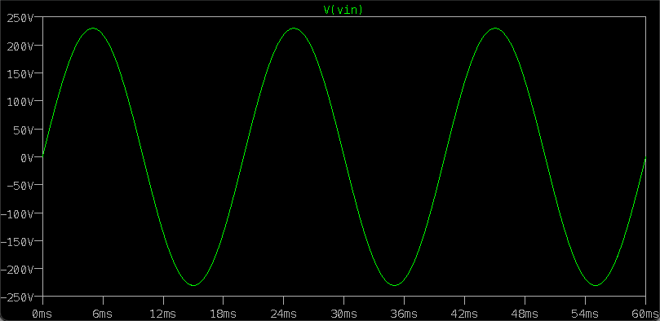

**Output Wave Form: -**

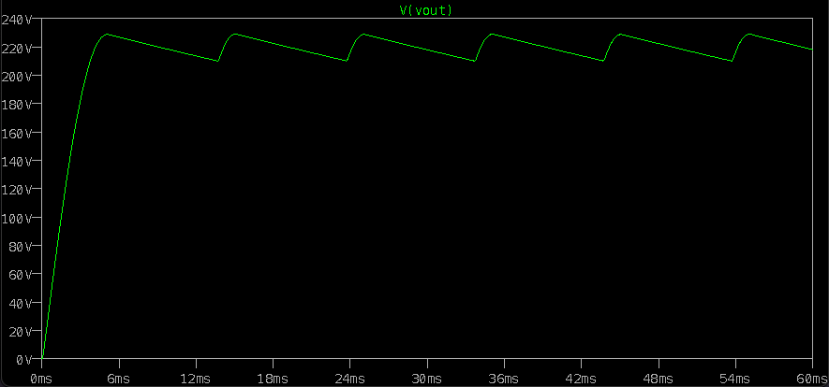

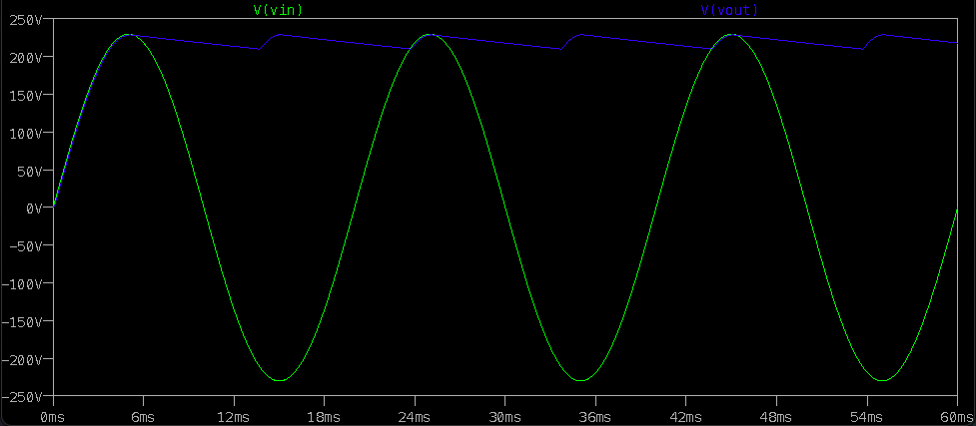

**INFERENCE**

**Operations Without Capacitor: -**

### **an ac input is applied to the primary coils of the transformer. This input makes the secondary ends P1 and P2 become positive and negative alternately. For the positive half of the ac signal, the secondary point D1 is positive, ground point will have zero volt and P2 will be negative. At this instant diode D1 will be forward biased and diode D2 will be reverse biased. As explained in the Theory Behind P-N Junction and Characteristics of P-N Junction Diode, the diode D1 will conduct and D2 will not conduct during the positive half cycle. Thus, the positive half cycle appears across the load resistance RL.**

### **During the negative half cycle, the secondary ends P1 becomes negative and P2 becomes positive. At this instant, the diode D1 will be negative and D2 will be positive with the zero reference point being the ground. Thus, the diode D2 will be forward biased and D1 will be reverse biased. The diode D2 will conduct and D1 will not conduct during the negative half cycle.**

### **Operations With Capacitor: -**

During both the half cycles, the diode pair will be in forward biased condition and the capacitor gets charged as well as the load gets supply. The interval of the instantaneous voltage at which the stored energy in capacitor is higher than the instantaneous voltage the capacitor supplies the stored energy in it. The more the energy storage capacity the lesser the ripple in the output waveform.

We can improve the average DC output of the rectifier while at the same time reducing the AC variation of the rectified output by using smoothing capacitors to filter the output waveform. Smoothing or reservoir capacitors connected in parallel with the load across the output of the full wave bridge rectifier circuit increases the average DC output level even higher as the capacitor acts like a storage device.

**RESULT: Full wave rectifier output and input characteristics with and without filter is verified.**